
Bruce. A Weinberg

Department of Economics
Ohio State University
1945 North High Street
Columbus, OH 43210-1172

Phone: (614) 292-5642
Fax: (614) 292-3906

April 2, 2012

Professor William Masters
E-mail to: Vankeerbergen.1@osu.edu

Dear Mitch:

This letter is to accompany the proposed Surveying and Mapping Minor. We discussed this minor at our February 16, March 15, and March 29 meetings. The minor was modified just before the switch from quarters to semesters and is (apparently) a straightforward conversion of the revised quarter minor. Bernadette made a valiant effort to piece together all of the changes, but the details remain a big murky, in part because Engineering never provided clear responses to our enquiries. That said, the changes are clearly driven by state requirements, the original quarter minor was available to ASC students, and our students (especially from Geography) are likely to continue to benefit from continued access to the minor. The SBS subcommittee approved the minor unanimously at our March 30 meeting.

Sincerely,
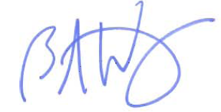
Bruce A. Weinberg
Professor and Director of Undergraduate Studies

